Supplementary material

Instrumented total knee replacement
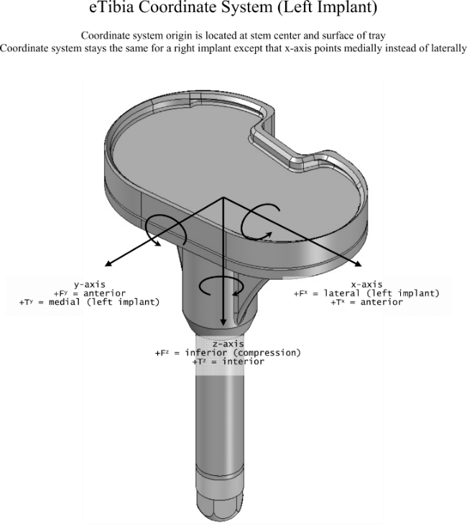
The implant data were originally sampled at 50 Hz but provided after being resampled to 200 Hz using a cubic-spline interpolation and filtered using a 4th order, low-pass Butterworth filter with a cut-off frequency of 15 Hz. The location and orientation of the load cell’s reference frame are shown in Figure 1.
Figure 1: The coordinate system fixed in the tibial tray and used to resolve the instrumented implant force and moment measurements. Image from Fregly et al. (2012).

Electromyography data
Electrode placement was consistent with (Delagi and Perroto, 1980). The data were sampled at 1000 Hz and provided after being high pass filtered at 30 Hz using a 4th order Butterworth filter. Subsequently, the offset of each signal was removed, a low-pass filter with a cut-off frequency of 400 Hz was applied and the signals were full-wave rectified. The data were then separately processed to obtain both the envelope trajectories and the EMG onset times: Envelope trajectories were obtained through applying a low-pass filter with a cut-off frequency of 4 Hz; After a low-pass filter with a cut-off frequency of 10 Hz, EMG onset times were defined as the time of the initial frame of a 50 ms sliding window at which the average value of the window exceeded a predefined threshold value (Hodges and Bui, 1996). For each muscle, the threshold value was defined, on a trial-by-trial basis, as three standard deviations increase from the average value of a period of visually inspected inactivity. All filters were 4th order, zero-lag Butterworth filters and implemented in MATLAB. To allow for a direct comparison of EMG data with muscle activations predicted by the musculoskeletal model, given that no activation dynamics was included, an electromechanical delay (EMD) of 60 ms was taken into account; values for EMD in lower-limb muscles reported in experimental literature varied from 40 to 80 ms (Vos et al., 1990; Zhou et al., 1995).
The following figures (Figure 2 - Figure 7) show, for individual trials, the muscle activation patterns for the muscles that span the knee and for which EMG data were available. The predicted activation patterns from the $J_{Fmatch}$, $J_{act}$ and the Metabolica samples were included.
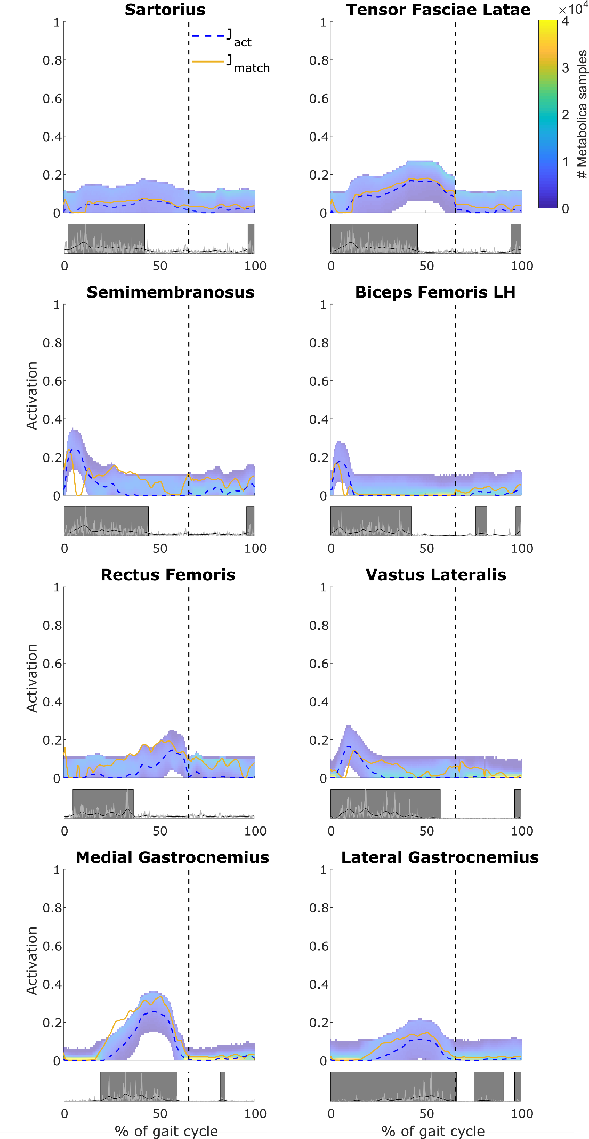
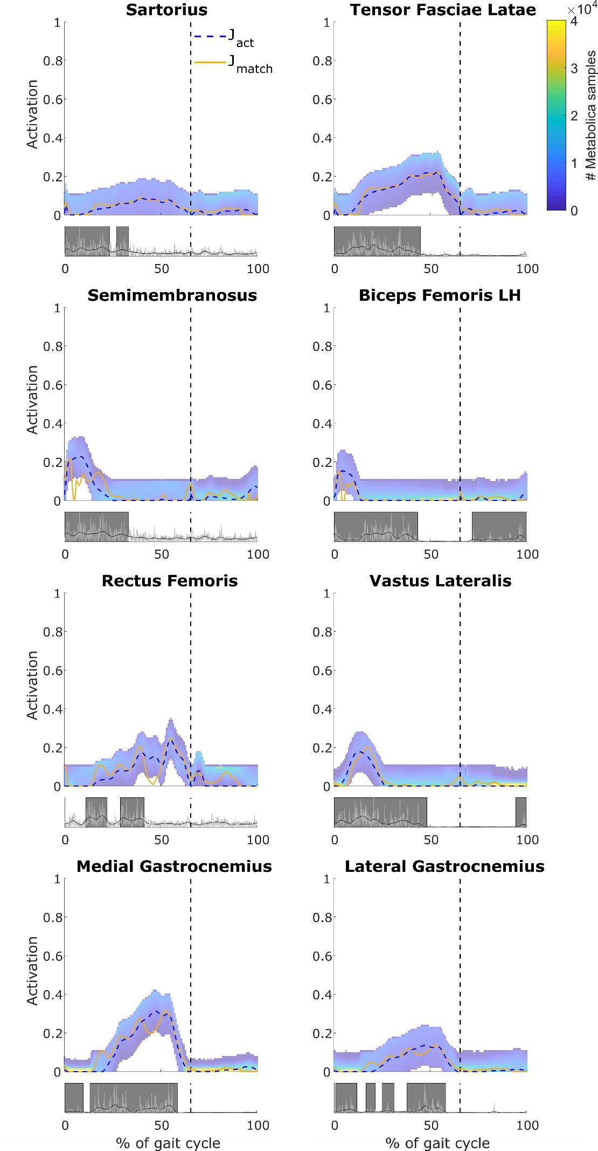
Figure 2: Trial 3, the activation patterns of the muscles that span the knee for which EMG data were available. For each muscle, the top graph shows the $J_{act}$ (blue, dashed) and $J_{Fmatch}$ (yellow, solid) solutions as lines and the sampled muscle activation patterns as a range for which the colour indicates the number of samples (see colour bar); the bottom graph shows the EMG data: the rectified values in light grey, the envelope in black and the onset timing as dark grey boxes. The vertical axis of the bottom graph was normalized to the maximum value in the rectified EMG data. The vertical dashed lines indicate the time instant when toe off occurred.
Figure 3: Trial 4, the activation patterns of the muscles that span the knee for which EMG data were available. For each muscle, the top graph shows the $J_{act}$ (blue, dashed) and $J_{Fmatch}$ (yellow, solid) solutions as lines and the sampled muscle activation patterns as a range for which the colour indicates the number of samples (see colour bar); the bottom graph shows the EMG data: the rectified values in light grey, the envelope in black and the onset timing as dark grey boxes. The vertical axis of the bottom graph was normalized to the maximum value in the rectified EMG data. The vertical dashed lines indicate the time instant when toe off occurred.
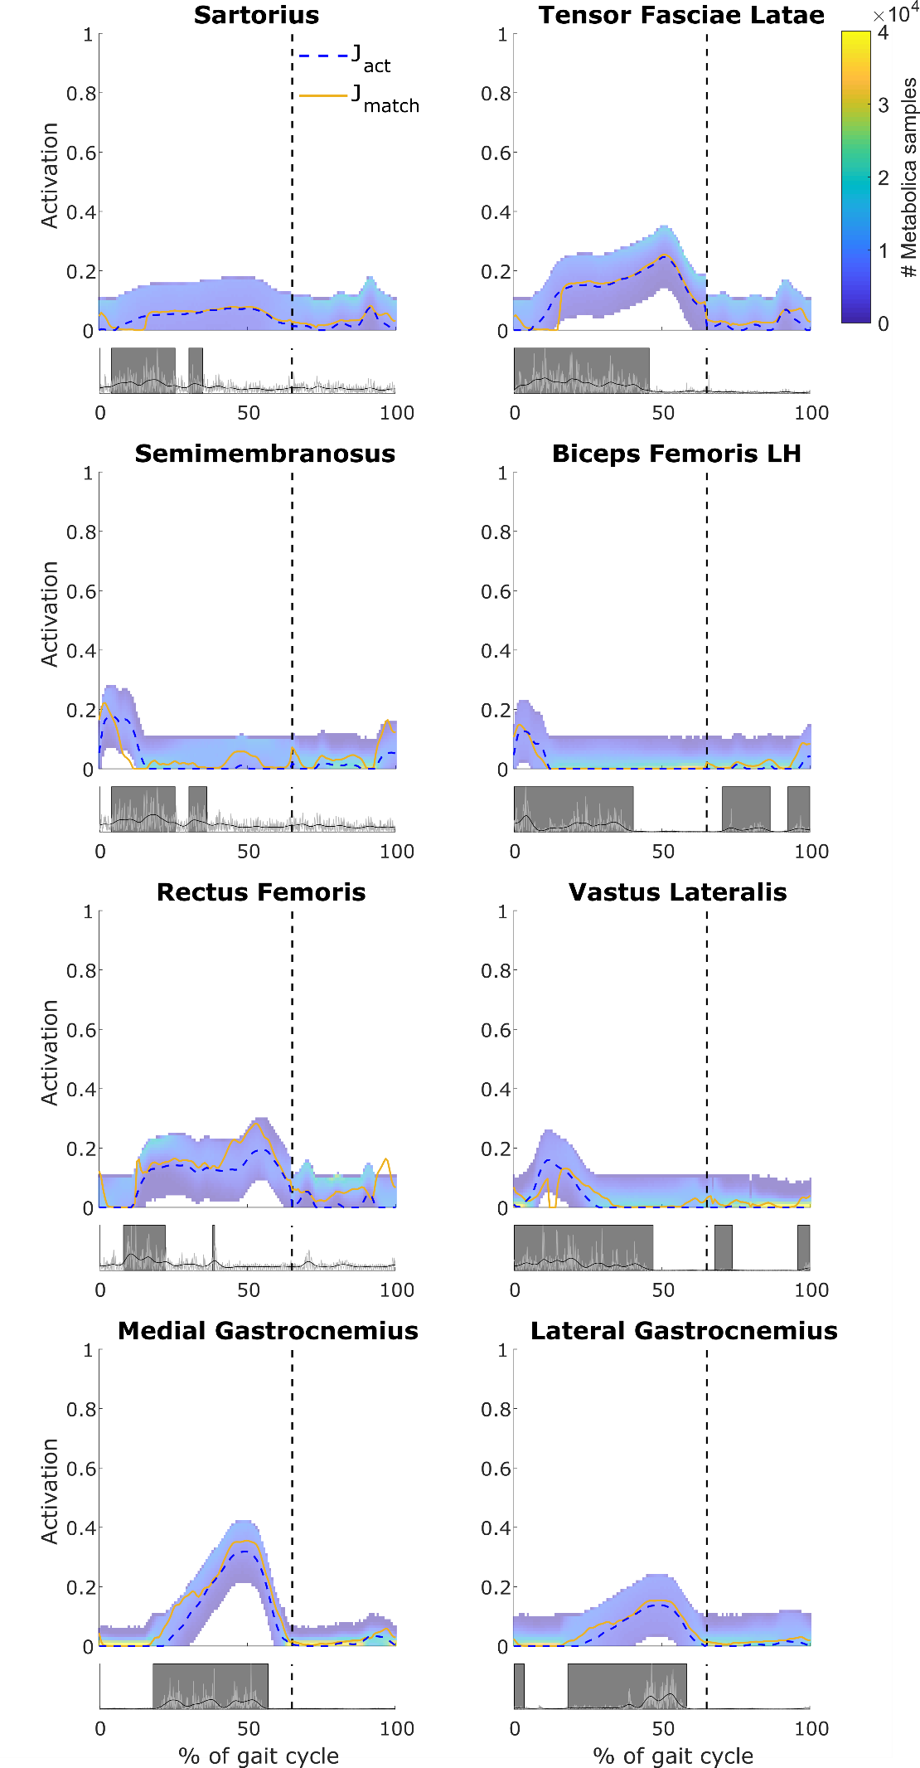
Figure 4: Trial 5, the activation patterns of the muscles that span the knee for which EMG data were available. For each muscle, the top graph shows the $J_{act}$ (blue, dashed) and $J_{Fmatch}$ (yellow, solid) solutions as lines and the sampled muscle activation patterns as a range for which the colour indicates the number of samples (see colour bar); the bottom graph shows the EMG data: the rectified values in light grey, the envelope in black and the onset timing as dark grey boxes. The vertical axis of the bottom graph was normalized to the maximum value in the rectified EMG data. The vertical dashed lines indicate the time instant when toe off occurred.
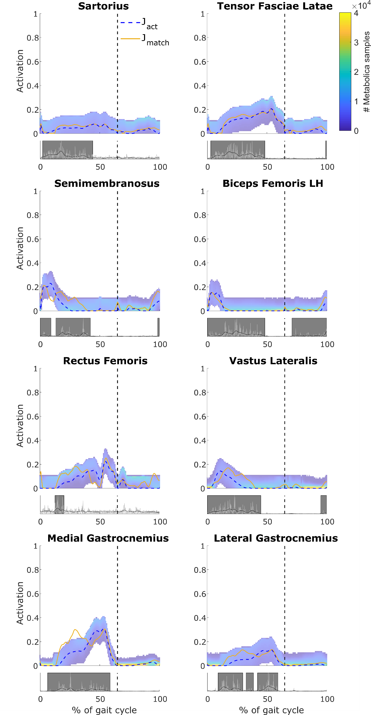
Figure 5: Trial 6, the activation patterns of the muscles that span the knee for which EMG data were available. For each muscle, the top graph shows the $J_{act}$ (blue, dashed) and $J_{Fmatch}$ (yellow, solid) solutions as lines and the sampled muscle activation patterns as a range for which the colour indicates the number of samples (see colour bar); the bottom graph shows the EMG data: the rectified values in light grey, the envelope in black and the onset timing as dark grey boxes. The vertical axis of the bottom graph was normalized to the maximum value in the rectified EMG data. The vertical dashed lines indicate the time instant when toe off occurred.
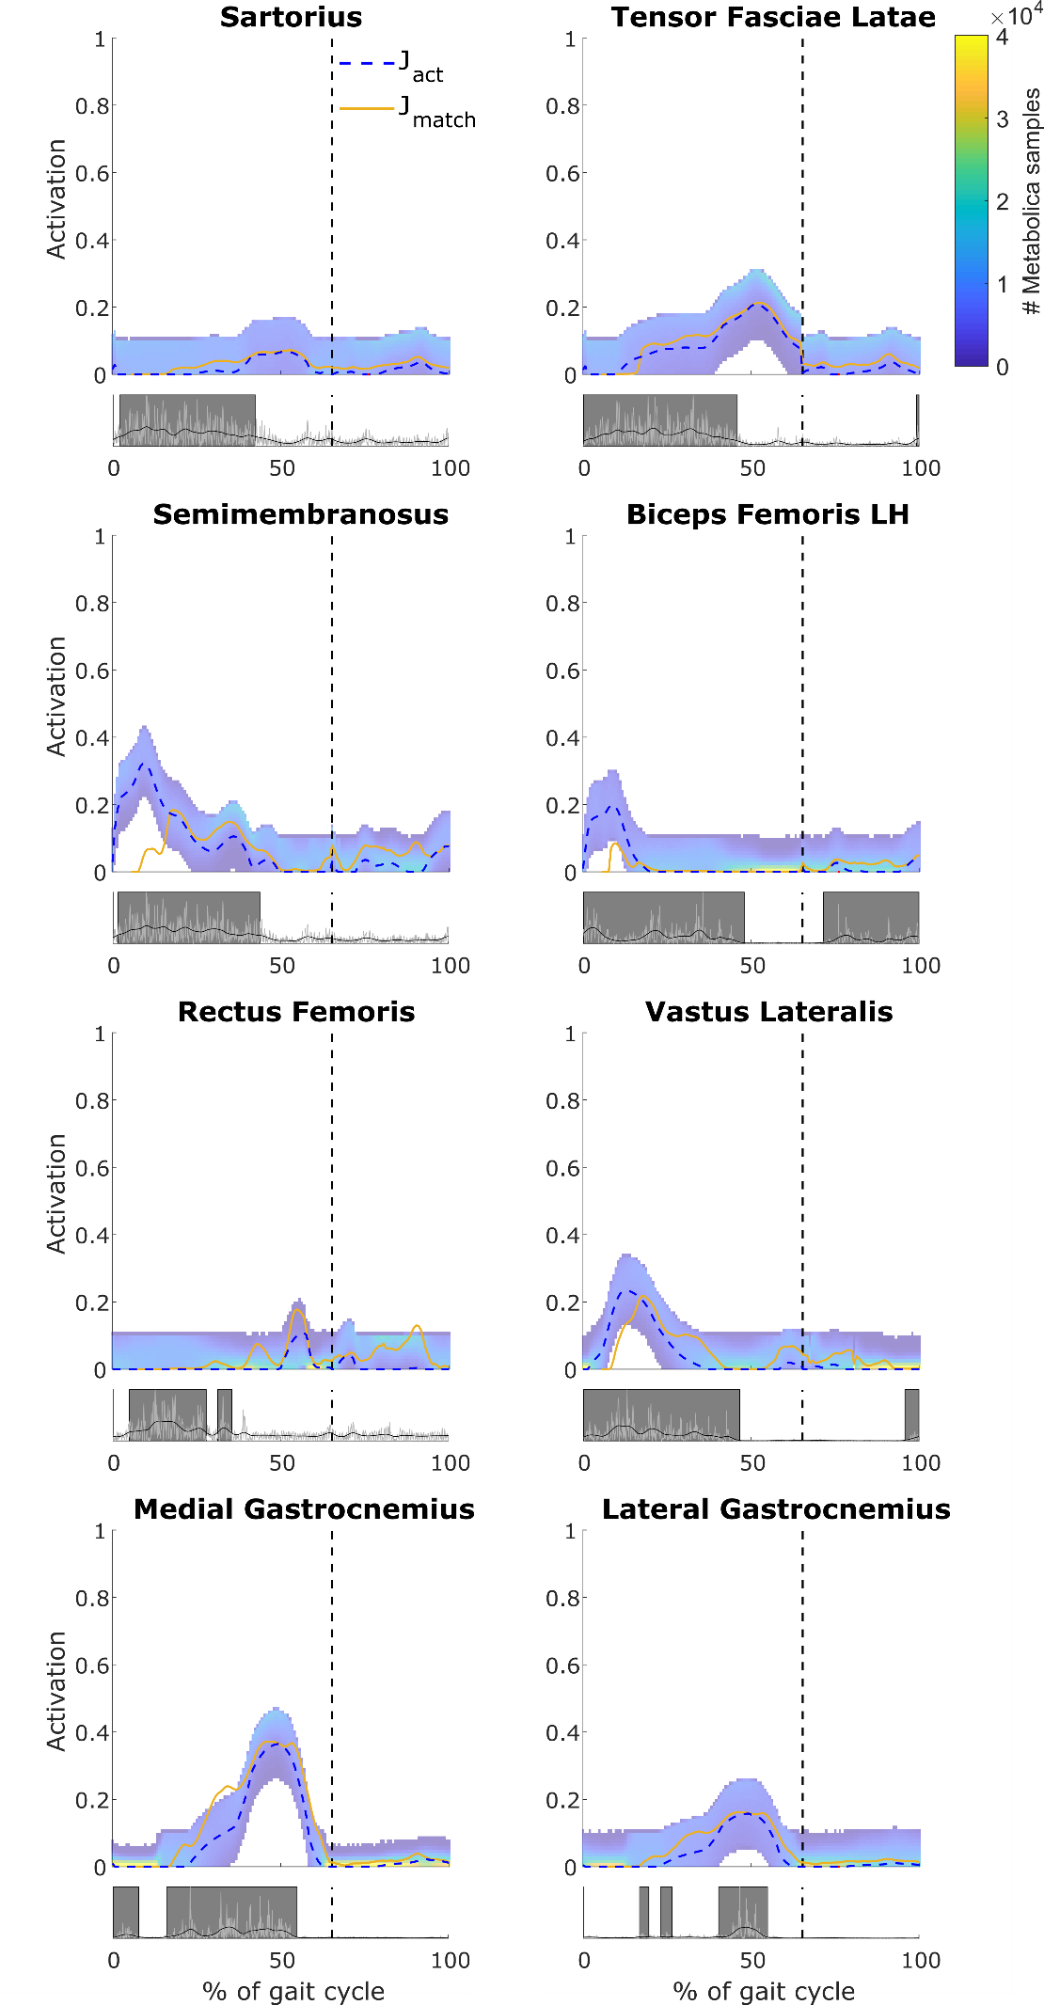
Figure 6: Trial 7, the activation patterns of the muscles that span the knee for which EMG data were available. For each muscle, the top graph shows the $J_{act}$ (blue, dashed) and $J_{Fmatch}$ (yellow, solid) solutions as lines and the sampled muscle activation patterns as a range for which the colour indicates the number of samples (see colour bar); the bottom graph shows the EMG data: the rectified values in light grey, the envelope in black and the onset timing as dark grey boxes. The vertical axis of the bottom graph was normalized to the maximum value in the rectified EMG data. The vertical dashed lines indicate the time instant when toe off occurred.
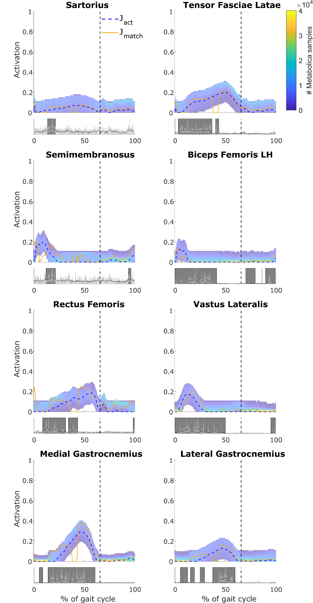
Figure 7: Trial 9, the activation patterns of the muscles that span the knee for which EMG data were available. For each muscle, the top graph shows the $J_{act}$ (blue, dashed) and $J_{Fmatch}$ (yellow, solid) solutions as lines and the sampled muscle activation patterns as a range for which the colour indicates the number of samples (see colour bar); the bottom graph shows the EMG data: the rectified values in light grey, the envelope in black and the onset timing as dark grey boxes. The vertical axis of the bottom graph was normalized to the maximum value in the rectified EMG data. The vertical dashed lines indicate the time instant when toe off occurred.

References
Delagi, E.F., Perroto, A., 1980. Anatomic Guide for the Electromyographer: The Limbs. Charles C Thomas Publisher, Springfield, Ill.
Hodges, P.W., Bui, B.H., 1996. A comparison of computer-based methods for the determination of onset of muscle contraction using electromyography. Electroencephalogr. Clin. Neurophysiol. Mot. Control 101, 511–519. https://doi.org/10.1016/S0921-884X(96)95190-5
Vos, E.J., Mullender, M.G., van Ingen Schenau, G.J., 1990. Electromechanical delay in the vastus lateralis muscle during dynamic isometric contractions. Eur. J. Appl. Physiol. Occup. Physiol. 60, 467–471. https://doi.org/10.1007/BF00705038
Zhou, S., Lawson, D.L., Morrison, W.E., Fairweather, I., 1995. Electromechanical delay in isometric muscle contractions evoked by voluntary, reflex and electrical stimulation. Eur. J. Appl. Physiol. Occup. Physiol. 70, 138–145. https://doi.org/10.1007/BF00361541

